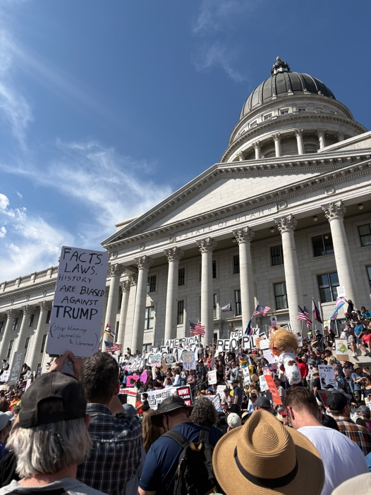

Lead in: With gas prices are souring, unlawful deportations and new federal cuts, Americans across the nation are confused with what the American Dream really is.
((Larieese: “I think as a megalomaniac narcissist who really wants to cause a great deal of harm, you can’t reason with him. You can’t change his mind.”))
Srey: People of all ages, colors and genders gather for the third “No Kings” protest March 28, 2026. With protests in all 50 states, millions rally to speak up against the unnecessary policies that the Trump Administration has enforced since Donald Trump’s reelection.

Srey: When looking back in American history, Americans chose a democracy over a monarch to keep a fair and lasting government. A system of check and balances is a three-branch system to help prevent judicial, executive or legislative take over, giving each branch different power.
Srey: The signing of the Declaration of Independence made the American people come together as one and fight against the corruption that comes with having a king.
((Arn: “No Kings” is exactly what the Declaration of Independence was all about. We did not want a king back in 1776, and we certainly don’t want one in 2027.”))
Srey: Today, Americans are using their voices to fight the Trump administration, accusing Donald Trump of wanting a dictatorship in the United States.
((Larieese: “I believe in our democracy, and I am concerned that we are watching it fall before our eyes. And the only way that we combat fascism is to resist and stand up and speak out.”))
Srey: With Trump’s “Big Beautiful Bill,” major changes continue to flow for the U.S. The Trump Administration markets the 10-year bill as cutting taxes, like tips and overtime and funding the Department of Homeland Security, but there’s much more that’s hurting millions of Americans.

Srey: Funding for Homeland Security came from somewhere, and this bill cut around 1 trillion dollars from Medicaid and 187 billion dollars from SNAP. Medicaid helps low-income families with medical needs, like yearly checkups, visiting the dentist and going to the eye doctor. SNAP benefits help over 40 million people in need of food assistance but now, an increase of poverty and hunger will spread across the United States. This big, ugly bill have millions advocating for a fair way of life.

Srey: This protest had tons of speakers to help others speak up. From former Utah Senate runner, Caroline Gleich to Samantha Reagan, organizer of the student group Mecha de U of U, people showed up to help make a change.
((Larieese: “I have hope. I think there are enough of us waking up at this point that we will stop an authoritarian takeover.”))

Srey: The environment and energy surrounding the capital is good and optimistic. From seeing children holding protest signs to meeting an old navy seal, you see a community, you gets chills from speakers and emotional for the state of this country. Dave Carrier, a Salt Lake resident, has gone to many protests. He attended the Minneapolis protest the day before Alex Pretti was shot by ICE agents and a Black Lives Matter protest after George Floyd was killed. Carrier says seeing the younger generation is a good sign for the future, but it’s necessary to care.

((Dave: “We have to speak up. You have to be willing to say up what you believe, what you think, and this country is incredibly misinformed.”))

Srey: Since Pres. Trump’s first presidential campaign in 2015, he has wanted a mass deportation of Latin Americans. Trump said it’s for “undocumented criminals” but has made it clear it could go farther.

Srey: People from all around the world come to the United States to live a good life and be successful for their families. Latin Americans have had to work extra hard to be taken seriously. They have boosted the United States economy with their culture, arts, labor and agriculture. If Pres. Trump wanted to deport all undocumented criminals, construction would take three time as long, crops would die, inflation would jump, people would lose their jobs and create chaos in the world.

((Valentina: “As a Latin American, a whole bunch of our ancestors and family members have come here to live the American dream. This isn't the American dream. We're getting targeted just for living here and trying to make a better life for ourselves, and I don't think that's fair.”))

Srey: The midterm elections are coming up this November. This midterm is important for the next two years of presidency because it could change the way Trump leads. With all 435 seats for House of Representatives and 1/3 of the Senate seats up for election, Congress could stop Trump from making certain moves and have him investigated if the democrats win the popular vote. While it would be hard to impeach the president, congress keeps the president in check by being able to override executive vetoes.

Srey: With how many people showing up to protest to how angry, disgusted and enraged they are, you see a community willing to fight back. The removal of signatures from Prop. 4 and saying no to changing Harvey Milk Boulevard shows Salt Lake residents that their voices and opinions do make a change.

((Dave: “We have to speak up. You have to be willing to say up what you believe, what you think, and this country is incredibly misinformed. There’s so many people who are repellent to facts.”))

Srey: Participating in protests, staying informed on the latest news and volunteering in local organizations are all ways people can help make a change. Donate to food banks and volunteer at homeless shelters to help others with a harder life. Make sure that you are registered to vote for the November midterms, because without our voices, no one can hear us speak.
((Hayley: “I know this is a scary time. I mean, just living in this time right now is scary as it is. So being able to voice your opinion seems even scarier, but it's important.”))

Citations
“$1 Trillion in Medicaid Cuts, $1 Trillion in Tax Giveaways for the Richest 1 Percent: The One Big Beautiful Bill’s Budget Math.” Center for American Progress, www.americanprogress.org/article/1-trillion-in-medicaid-cuts-1-trillion-in-tax-giveaways-for-the-richest-1-percent-the-one-big-beautiful-bills-budget-math/
“About No Kings.” No Kings, www.nokings.org/about-nk
“Branches of Government.” USA.gov, www.usa.gov/branches-of-government
“By the Numbers: Harmful Republican Megabill Takes Food Assistance Away from…” Center on Budget and Policy Priorities, www.cbpp.org/research/food-assistance/by-the-numbers-harmful-republican-megabill-takes-food-assistance-away-from
Metcalf, Kathy.
“March to Utah Capitol for ‘No Kings’ Rally.” Utah News Dispatch, 28 Mar. 2026, https://utahnewsdispatch.com/2026/03/28/march-to-utah-capitol-for-no-kings-rally/
NPR. “ICE Budget Funding Congress Trump.” NPR, 21 Jan. 2026, https://www.npr.org/2026/01/21/nx-s1-5674887/ice-budget-funding-congress-trump.
“Protect Medicaid.” Legal Action Center, www.lac.org/news/protect-medicaid-2025
UnidosUS. “Workforce Development.” UnidosUS, https://unidosus.org/issues/workforce-development/. Accessed 14 Apr. 2026.
U.S. Election Assistance Commission. “Vote.gov.” Vote.gov, https://vote.gov/. Accessed 14 Apr. 2026.
U.S. Vote Foundation. “What Are Midterm Elections?” U.S. Vote Foundation, https://www.usvotefoundation.org/what-are-midterm-elections. Accessed 14 Apr. 2026.

